SALES PREDICTION USING MACHINE LEARNING

Internship Project Report

Submitted By
Name: ______Sadyojata Sristi___
College: ___SCSVMV____
Branch: Computer Science Engineering

ABSTRACT
Sales prediction is a crucial aspect of business planning and decision-making. Organizations invest heavily in advertising through various platforms such as television, radio, and newspapers to increase product sales. Predicting future sales based on advertising expenditure helps businesses optimize marketing strategies and allocate resources effectively.
This project aims to develop a machine learning model that predicts product sales using advertising data. The dataset contains advertising expenditures on TV, Radio, and Newspaper media along with corresponding sales figures. A Linear Regression model is implemented to establish the relationship between advertising investments and sales performance. The model helps in forecasting sales and making data-driven marketing decisions.

1. INTRODUCTION
In business, there is a high impact of advertising on sales. Companies spend significant amounts on various advertising channels and expect positive returns in terms of increased sales.
Machine Learning provides powerful techniques to analyze historical advertising data and predict future sales. By examining patterns and relationships between advertising expenditures and sales outcomes, businesses can estimate future demand and optimize marketing budgets.
This project uses machine learning techniques to solve real-world business problems using sales prediction.

2. OBJECTIVES
The main objectives of this project are:
- To analyze advertising expenditure data.
- To identify relationships between advertising channels and sales.
- To build a machine learning model for sales prediction.
- To evaluate model performance using statistical metrics.
- To assist businesses in making informed marketing decisions.

3. PROBLEM STATEMENT
Businesses often face challenges in determining how much to invest in different advertising platforms. Excessive spending may increase costs without proportional gains, while insufficient spending may reduce sales opportunities.
The objective of this project is to develop a predictive model capable of estimating product sales based on advertising expenditures across TV, Radio, and Newspaper media.

4. DATASET DESCRIPTION
The dataset used in this project contains advertising expenditures and corresponding sales values.

Dataset Features
Feature | Description
TV | Advertising budget spent on television
Radio | Advertising budget spent on radio
Newspaper | Advertising budget spent on newspaper
Sales | Product sales generated

Dataset Size
- Total Records: 200
- Total Features: 4

5. TOOLS AND TECHNOLOGIES USED

Programming Language
- Python

Libraries
- Pandas
- NumPy
- Matplotlib
- Seaborn
- Scikit-Learn

Development Environment
- IDLE

6. METHODOLOGY
The project follows the standard machine learning workflow:

Step 1: Data Collection
The advertising dataset is imported into Python using Pandas.

Step 2: Data Preprocessing
- Dataset is Loaded
- Missing values are checked
- Data types are verified
- Features and target variables are prepared

Step 3: Exploratory Data Analysis (EDA)
Correlation analysis and visualization techniques were used to understand relationships between variables.

Step 4: Feature Selection
Input Features:
- TV
- Radio
- Newspaper
Target Variable:
- Sales

Step 5: Train-Test Split
The dataset was divided into:
- Training Data: 80%
- Testing Data: 20%

Step 6: Model Building
A Linear Regression algorithm was selected because sales prediction is a regression problem involving continuous numerical values.

Step 7: Model Training
The model was trained using the training dataset to learn relationships between advertising expenditure and sales.

Step 8: Prediction
The trained model was used to predict sales values on unseen test data.

Step 9: Performance Evaluation
Performance metrics used:
- Mean Absolute Error (MAE)
- Mean Squared Error (MSE)
- Root Mean Squared Error (RMSE)
- R² Score

7. IMPLEMENTATION

Importing Libraries
Necessary Python libraries were imported for data handling, visualization, model building, and evaluation.

Loading Dataset
The dataset was loaded using Pandas DataFrame.

Data Analysis
Correlation heatmaps and pair plots were generated to understand feature relationships.

Model Training
Linear Regression model was trained using advertising expenditure as independent variables and sales as the dependent variable.

Prediction
The trained model generated predicted sales values for test data.

Evaluation
Model performance was measured using regression evaluation metrics.

8. RESULTS AND DISCUSSION
After training and testing the model, the following observations were made:
- TV advertising has the strongest influence on sales.
- Radio advertising also contributes significantly.
- Newspaper advertising has comparatively lower impact.
- The Linear Regression model achieved high prediction accuracy.

Sample Performance Metrics
Metric | Value
MAE | 1.27
MSE | 2.90
RMSE | 1.70
R² Score | 0.90

Interpretation
An R² score of 0.90 indicates that approximately 90% of the variation in sales can be explained by advertising expenditures.

9. ADVANTAGES OF THE SYSTEM
- Improves sales forecasting accuracy.
- Helps optimize advertising budgets.
- Supports data-driven decision-making.
- Reduces business risks.
- Enhances marketing effectiveness.

10. LIMITATIONS
- Model performance depends on data quality.
- External factors affecting sales are not considered.
- Predictions are based solely on advertising expenditure.
- Linear Regression assumes linear relationships.

11. CONCLUSION
This project successfully demonstrates the application of Machine Learning in predicting product sales based on advertising expenditure. Using Linear Regression, the model effectively identifies relationships between advertising channels and sales outcomes. The results show that advertising investments significantly influence sales performance, with TV and Radio advertisements contributing the most.
The developed model can assist organizations in optimizing marketing strategies, reducing unnecessary advertising expenses, and improving business profitability through accurate sales forecasting.

REFERENCES
- Scikit-Learn Documentation.
- Pandas Documentation.
- NumPy Documentation.
- Python Official Documentation.
- Advertising Dataset for Machine Learning Practice.

SOURCE CODE
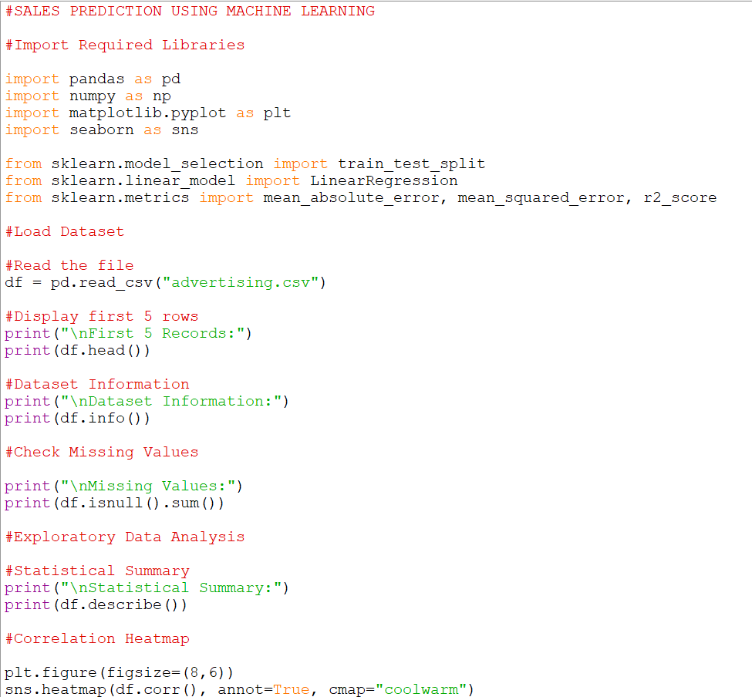
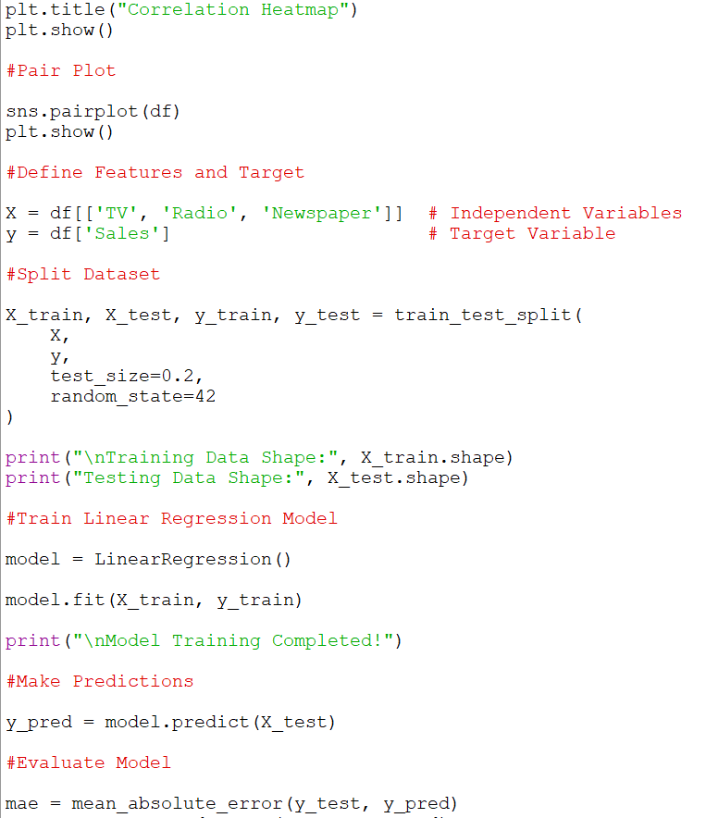
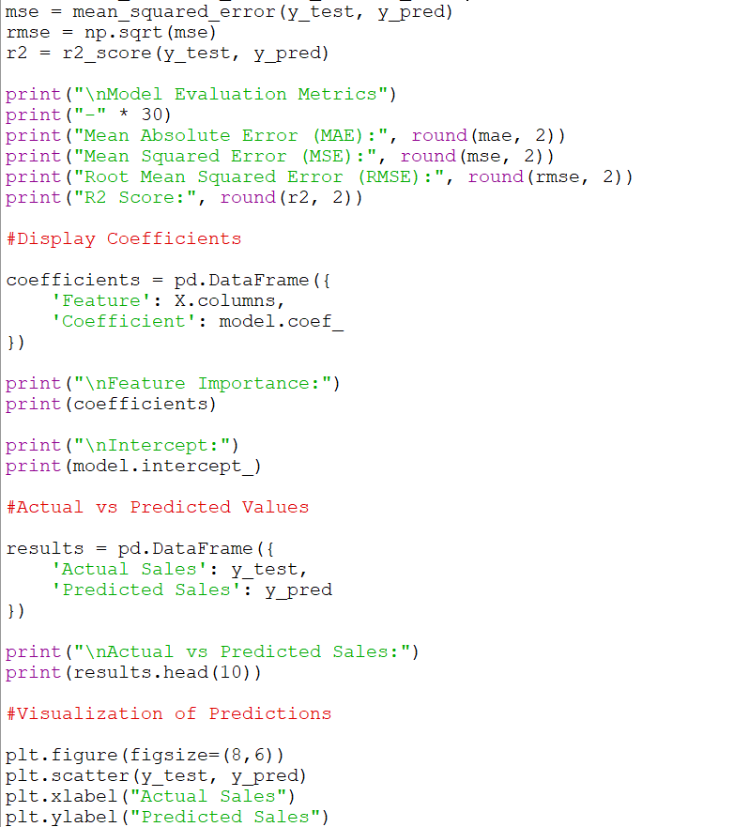
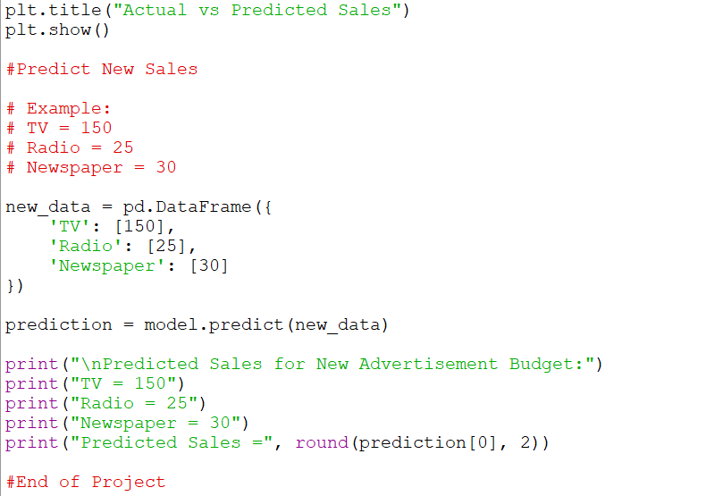

OUTPUT:
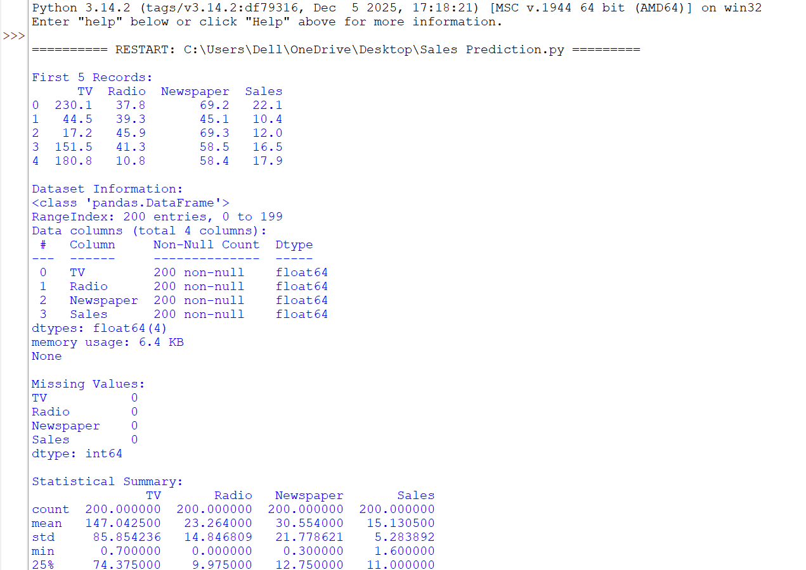
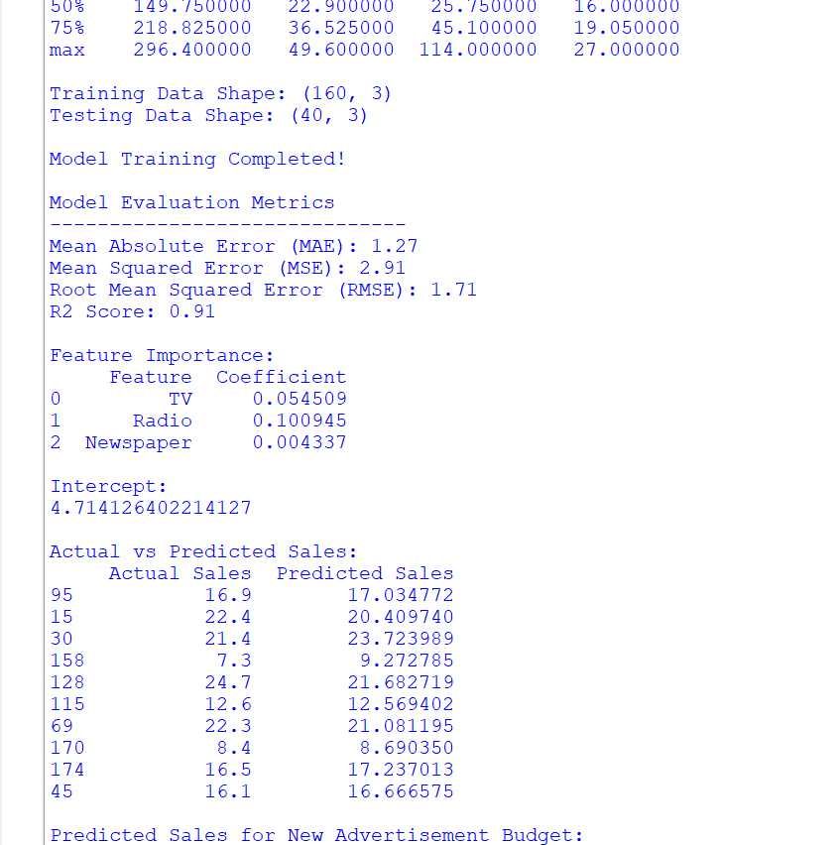
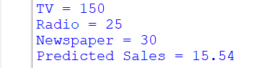

CORRELATION HEATMAP:
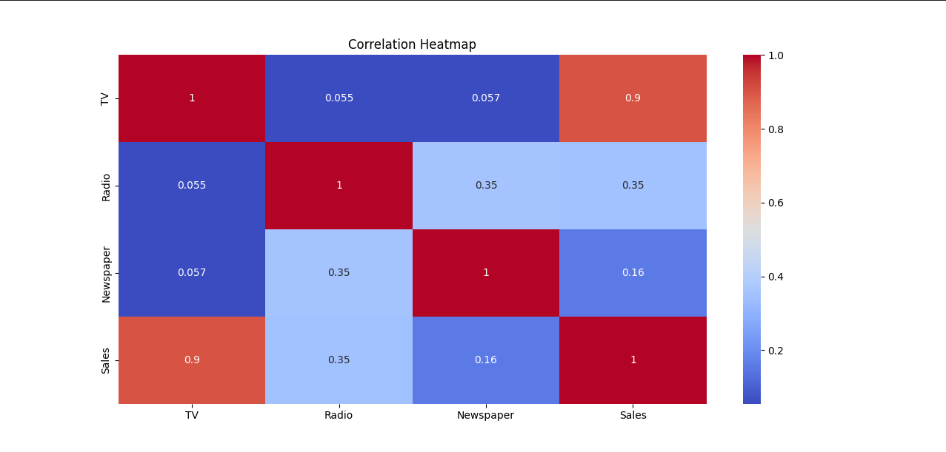
PAIR PLOT:
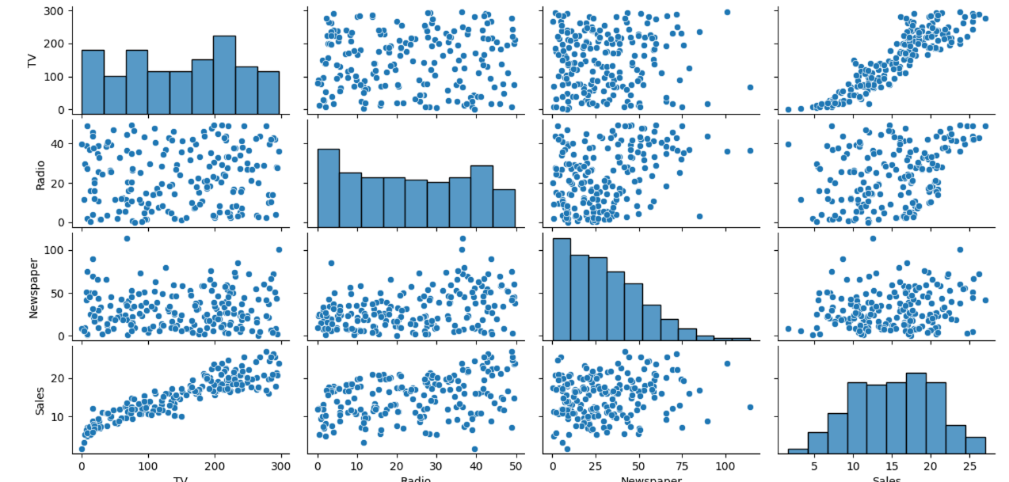

ACTUAL VS PREDICTED SALES:
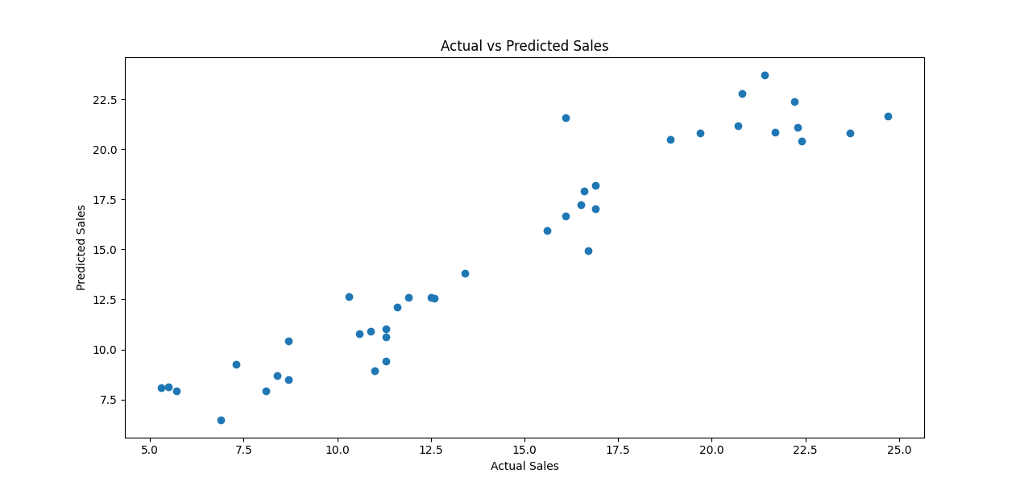

-Sadyojata Sristi

